CSE25-212 TSHEPANG SEGOBAETSO

FUNCTIONAL REQUIREMENTS
Customer and Account Requirements
FR-1 The system must allow a customer to open an account with the bank.
FR-2 The system must allow a customer to have multiple accounts, such as a Savings Account, Investment Account and Cheque Account.
FR-3 An account cannot exist without being held by a customer.
FR-4 The system must allow customers to register their personal information before using the banking services.
FR-5 The system must allow users to log in and access their banking information through authentication.
FR-6 The system must allow customers to view information about the accounts they hold.

Savings Account Requirements
FR-7 The system must allow a customer to open a Savings Account.
FR-8 The system must allow a customer to deposit funds into a Savings Account.
FR-9 The Savings Account must pay monthly interest based on the balance in the account.
FR-10 The system must not allow withdrawals from a Savings Account.
FR-11 The system must apply the specified monthly interest rate of 0.05% to the Savings Account.

Investment Account Requirements
FR-12 The system must allow a customer to open an Investment Account.
FR-13 The system must allow a customer to deposit funds into an Investment Account.
FR-14 The system must allow a customer to withdraw funds from an Investment Account.
FR-15 The Investment Account must require an initial deposit of BWP500.00 before it can be opened.
FR-16 The Investment Account must pay a higher interest rate than the Savings Account.
FR-17 The system must apply the specified monthly interest rate of 5% to the Investment Account.
Cheque Account Requirements
FR-18 The system must allow a customer to open a Cheque Account.
FR-19 The Cheque Account must be available only to customers who are working.
FR-20 The system must capture the customer's employment information when opening a Cheque Account.
FR-21 The employment information must include the company where the customer works and the company address.
FR-22 The system must allow deposits into a Cheque Account.
FR-23 The system must allow withdrawals from a Cheque Account.
FR-24 The Cheque Account must allow deposits and withdrawals of any amount.
FR-25 The system should allow the Cheque Account to be used for receiving salary payments.

Deposit and Transaction Requirements
FR-26 The system must allow a customer to make deposits into any or all of the accounts they hold.
FR-27 The system must process deposits according to the rules of the particular account type.
FR-28 The system must record the customer's banking transactions.
FR-29. The system must allow a customer to view their transaction history.
FR-30. The system must update the account balance after a successful transaction.

Interest Requirements
FR-31 The system must calculate and pay interest to the appropriate accounts.
FR-32 The system must apply the correct interest rate according to the type of account.
FR-33 The system must calculate the monthly interest using the balance of the applicable account.

NON-FUNCTIONAL REQUIREMENTS
NFR-1 The system must require a password to prevent unauthorised individuals from accessing customer accounts.
NFR-2 The system must be easy to use, and customers must be able to use it after being shown a simple tutorial.
NFR-3 The system must always be available and remain stable for long periods of time.
NFR-4 The system must be fixable when it encounters any problems or errors.
NFR-5 The system must be able to run across different environments, including supported devices.
NFR-6 Customer details should be encrypted to provide security and protect customer privacy.
NFR-7 The system must be able to process customer requests and transactions within a reasonable amount of time.
NFR-8 The system must be able to recover from errors without losing customer information or transaction records.
NFR-9 The system must ensure that deposits and other permitted transactions are processed accurately.
NFR-10 The system must prevent unauthorised individuals from viewing or changing customer information.
NFR-11 The system must keep a record of transactions to allow customers to view their transaction history when needed.
NFR-12 The system must be able to handle multiple customers accessing the system without affecting its performance.
NFR-13 The system must ensure that customer account balances are updated correctly after successful transactions.
NFR-14 The system must be easy to update and maintain when changes or improvements are needed.

INTERVIEW
Interview: Banking Management System
Interviewee: Family Menber
Interviewer: Student
Interview Questions and Responses
1. Interviewer: Could you briefly explain some of the main services that your bank provides to customers?
Interviewee: We offer several services, including opening bank accounts, depositing and withdrawing money, transferring funds, checking account balances, processing payments and providing customers with bank statements. We also offer different types of accounts depending on the customer's needs.
2. Interviewer: What types of bank accounts are commonly offered?
Interviewee: The most common ones are savings accounts, cheque accounts and investment accounts. Each account serves a different purpose. For example, savings accounts are mainly for customers who want to save money, while cheque accounts are useful for everyday transactions. Investment accounts are generally intended for customers who want to invest their money and earn interest.
3. Interviewer: How does a customer normally open a bank account?
Interviewee: A customer first provides their personal information and identification documents. Depending on the type of account, additional information may be required. For example, someone opening a cheque account may need to provide employment details. The bank then verifies the information before approving the account.
4. Interviewer: How are deposits and withdrawals handled?
Interviewee: Customers can deposit money through different banking channels, such as visiting a branch or using an ATM. Withdrawals can also be made at ATMs or through other available banking services. Every transaction should be recorded so that the customer's account balance remains accurate.
5. Interviewer: What happens when a customer wants to transfer money to another account?
Interviewee: The customer provides the recipient's account details and the amount they want to transfer. The system should verify that the recipient's account is valid and that the sender has enough money. Once everything is confirmed, the money is transferred and the transaction is recorded.
6. Interviewer: How does the bank protect customers' accounts from unauthorised access?
Interviewee: Security is very important in banking. Customers normally use login credentials, PINs and other verification methods to access their accounts. The bank also needs to ensure that sensitive customer information is protected and that only authorised people can access certain information.
7. Interviewer: Do customers sometimes experience problems when using banking services?
Interviewee: Yes, it happens. Sometimes customers experience delays when transactions are being processed, forget their login details or have difficulties accessing their accounts. There can also be situations where transactions fail or customers need assistance understanding certain banking services.
8. Interviewer: How are customer transactions and account activities monitored?
Interviewee: Transactions are recorded in the customer's transaction history. This allows both the bank and the customer to keep track of deposits, withdrawals, transfers and payments. It is also useful when investigating disputed transactions or checking previous account activities.
9. Interviewer: What information should bank employees be able to access when assisting customers?
Interviewee: Employees should be able to access relevant customer details, account information and transaction records, depending on their responsibilities. They may also need to update customer information, assist with account-related enquiries and generate reports. However, access should be controlled to protect customer privacy.
10. Interviewer: If you could improve the current banking system, what changes would you suggest?
Interviewee: I would suggest making the system easier to use and improving how quickly information is accessed. It should also reduce unnecessary manual work, make transaction records easier to retrieve and provide reliable reports. Most importantly, it should be secure and accurate because even a small mistake involving money can cause serious problems

USE CASE DIAGRAM

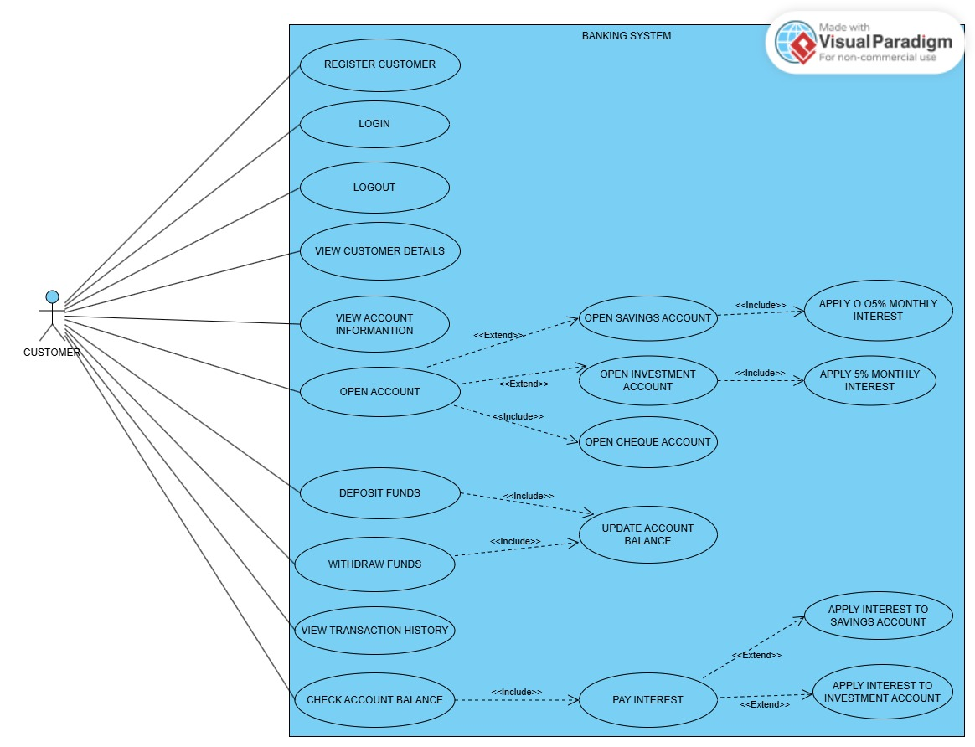

CLASS DIAGRAM
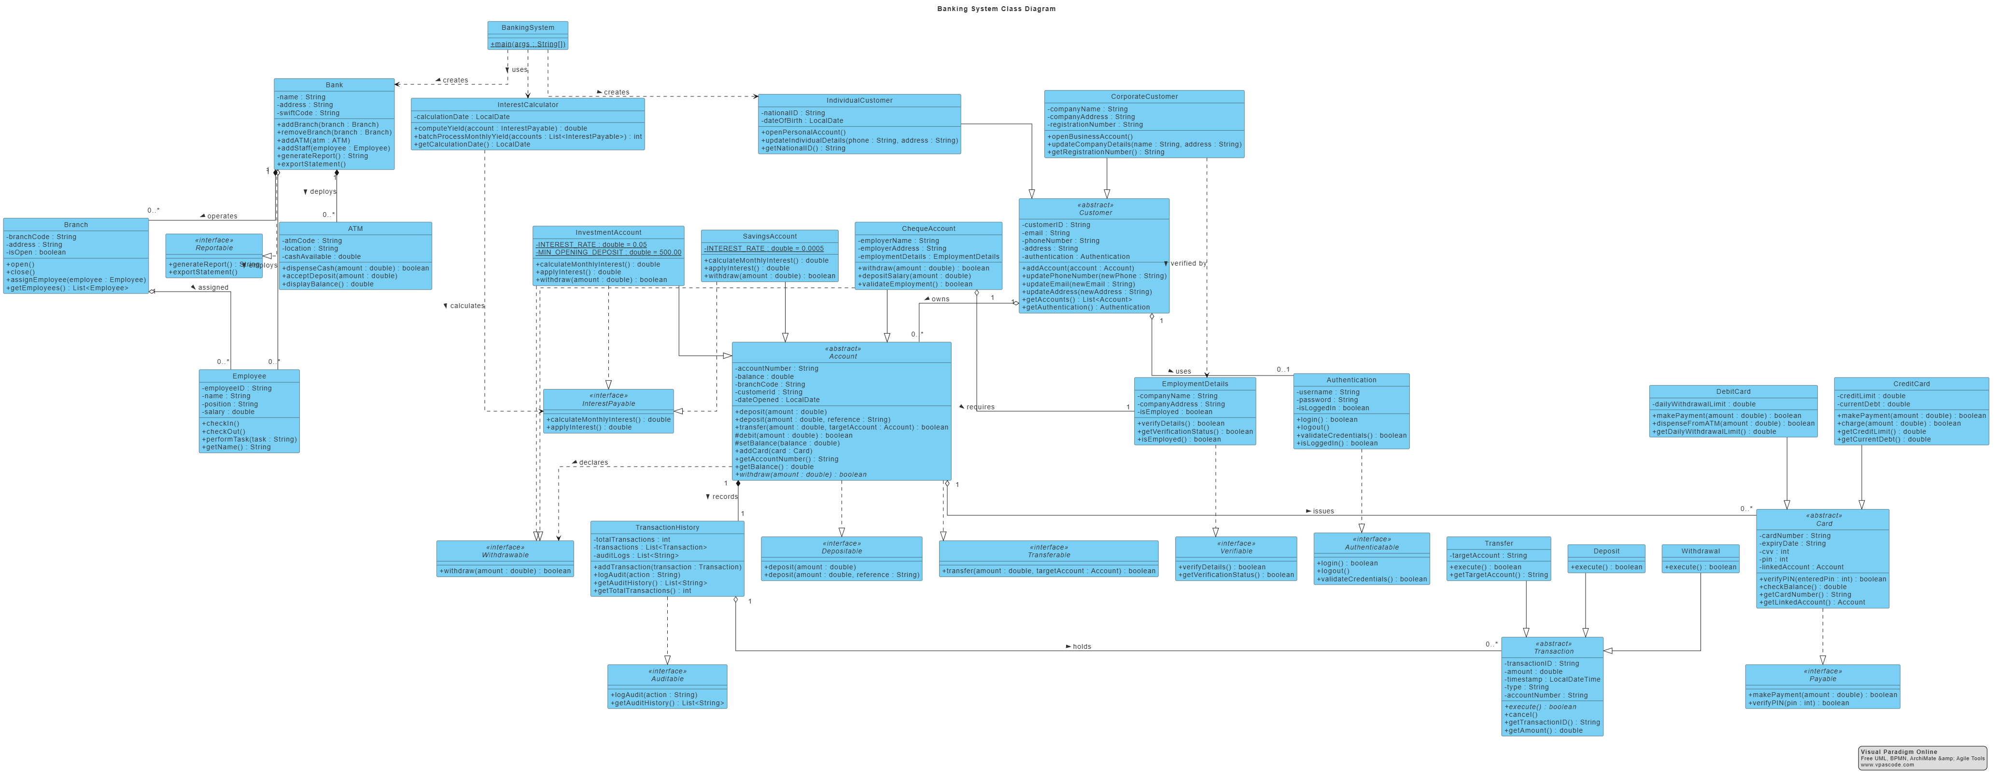

SEQUENCE

1.DEPOSIT SEQUENCE DIAGRAM

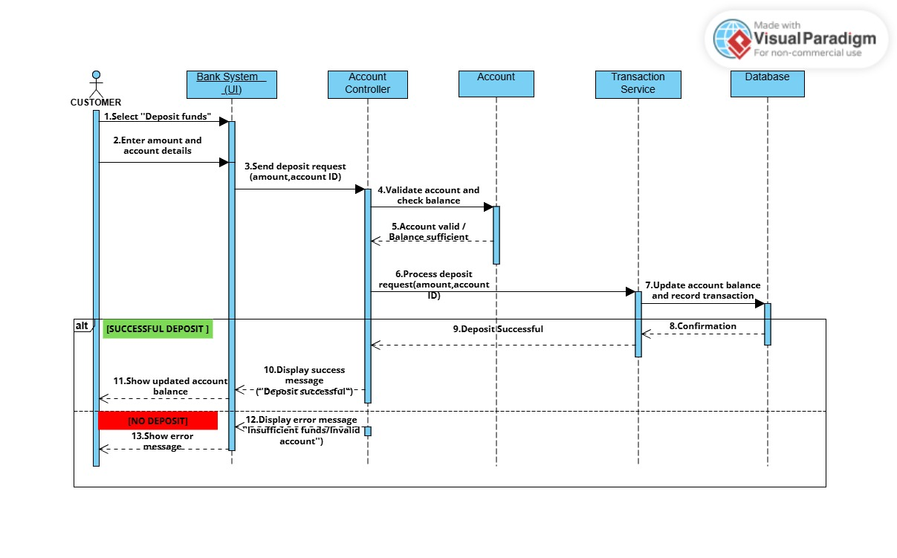

2. LOG-IN SEQUENCE DIAGRAM

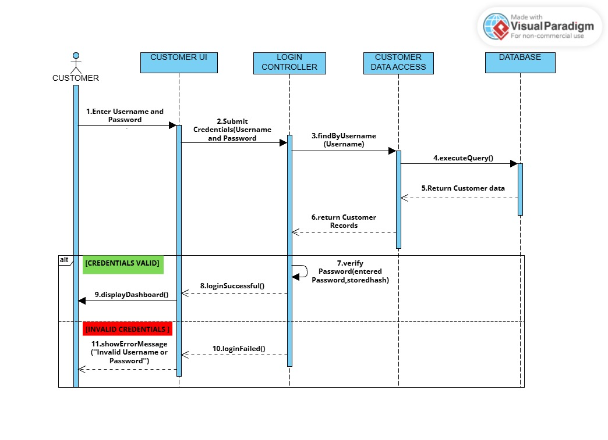
STATE DIAGRAM

